Programming for Computer Games

Question1

1. Unity and Unreal engine.

The game engine selected was unity because:

* The first reason was that unity can be 2D or 3D while unreal engine is only 3D.
* Another advantage that Unity can be scripted in C# and JavaScript while unreal engine can only be scripted in C++.
* Another advantage is that Unity can support a lot of platforms like Windows, Linux, OS X and etc. While unreal engine can only use cross platform.
* The structure of Unity is easy to understand and runs faster.

1. C# and C++.

The one chosen is C# and its features are:

* Simple
* Modern
* Type safe
* Object orientated

Question2

A.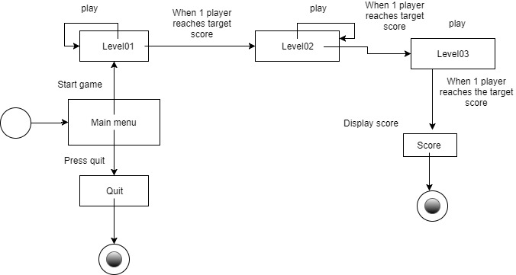

B.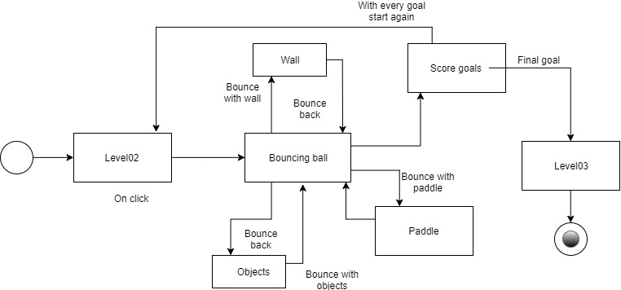

Question3

Compression is needed when using media assets so it can perform faster in network due to its highly reduced file size. The file is reduced by using tools and techniques of various media formats. Compression is also needed so it can use less bandwidth and this means that the transfer speed will be faster. The compression also reduces the deploy time for debugging a game. Compressed files are also needed so they can be sent as email. Some internet servers need only compressed files to download or upload them. Compressed files also reduce time to attach, download and upload files.



References

# (Microsoft, 2017)

(careerride, 2012)

(Lancett, 2017)

(Wikipedia, 2017)